# Installation Guide: Git

## Install Git

### Install Git on Window

Visit the following website: <https://git-scm.com/downloads>.

Once you have downloaded the .exe file, open it and chose the following options, when asked for them:

* "Use Git Bash Only"
* "Checkout Windows-style, Commit Unix-style Endings"



### Install Git on Linux

**sudo apt-get install git**

### Install Git on macOS

There are several ways to install Git on macOS. Take a look at them by following the links below and chose the one that is most appropriate for you:

<https://git-scm.com/download/mac>

<https://www.atlassian.com/git/tutorials/install-git>

## Install TortoiseGit/TortoiseSVN

### TortoiseGit

TortoiseGit is a GUI for the Git version control system. If you only want to use Git, you only need to install TortoiseGit from this link: <https://tortoisegit.org/download/>

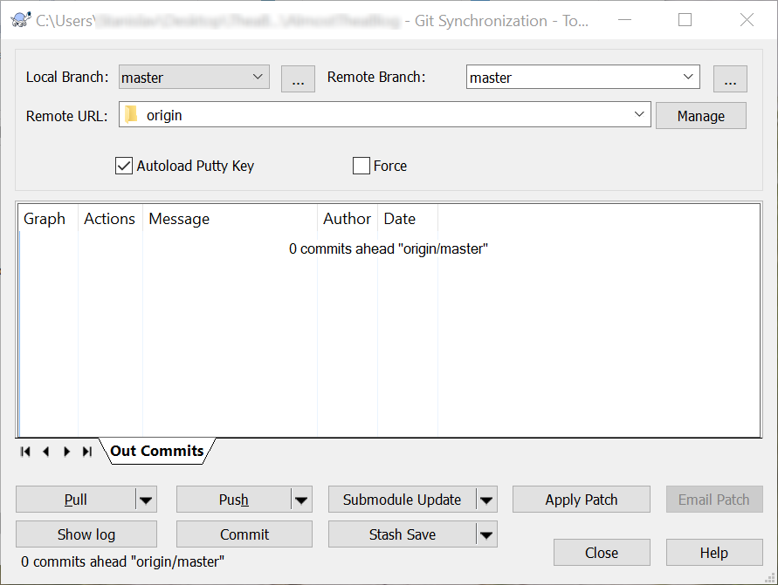

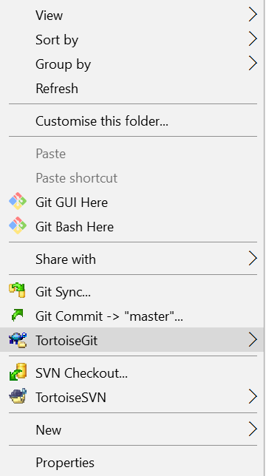 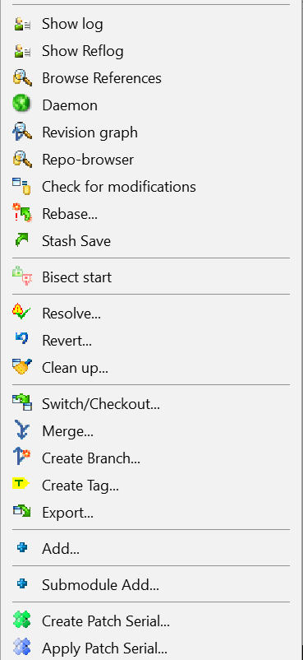

### TortoiseSVN

TortoiseSVN is a graphical user interface (GUI) for the Subversion version control system. If you also want to work with Subversion repositories, you can install TortoiseSVN from this link: <https://tortoisesvn.net/downloads.html>